“The Grinder”

3/4hp Garbage Disposal

Project Graphic:

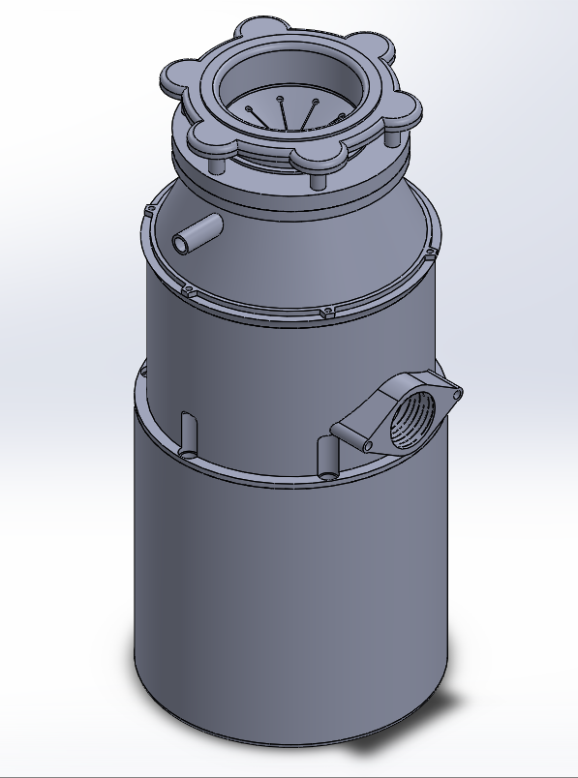

Dynamics

Ryan Fuglvog

Cedarcrest High School

1/26/21

1. **Introduction (2 points)**
   1. Introduction paragraph(s) gives an overview of the project. Tell what the project is in general and specific terms.

To an average onlooker this might look like another run of the mill garbage disposal, but I can assure you that this garbage disposal’s great design as well as a fast and easy assembly is nothing to scoff at. For starters, “the grinder boasts a whopping 3/4HP electric motor satisfying all of your grinding needs. Standing a just under a foot in

1. **Target Market (2 points)**
   1. Give a description of who would use the product and / or a customer list. (It could be a design for one specific user.)

This product is great for anyone looking to remodel their kitchen or sink. People may also just be looking for a better disposal, really anyone that needs a proper disposal, one that will last and won’t break. I think I hit the mark when it comes to creating something that would be both functional and appealing.

1. **Requirements (4 points)**
   1. Tell what requirements you were trying to have your project meet.
   2. Give specific and appropriate supporting details. Use as many paragraphs as needed to fully explain. (You may also embed screen shots.)

My main goal for the garbage disposal was really just to see how well I could make it function adding all the parts that a real garbage disposal would have. And honestly, just to have some fun with something that was random and unique. When it comes to the garbage disposal itself I needed to make sure that it had the base set of functioning parts. This includes ball bearings or something that would allow a shaft to spin freely and

1. **Product Ideas (4 points)**
   1. How did you come up with your product? What were some ideas you had when developing your design?

I thought a garbage disposal would be a fun thing to model both unique and posing some interesting challenges when modeling. I had also thought about doing something larger such as an engine or something with a mechanical aspect to it but ultimately decided on the garbage disposal as I could easily get measurements to get correct dimensions for the disposal. This also helped me create a more realistic and marketable product.

4.2

Describe how you decided on the project, how you met the requirements with your design.

I knew that I wanted to do something mechanical I thought about doing an engine but I felt like I wasn’t ready to build something like that without a large amount of outside help so I went for something simpler while maintaining the mechanical aspect of the design. I thought about a few different ideas but eventually settled on a garbage disposal for no good reason other that I found it to fit my first two requirements with the addition that it was something unique. Also, because I have a garbage disposal in my house, I can easily dimension the model to be realistic in terms of how it looks, assembles, and functions.

1. **Product Sketches (4 points)**
   1. Include your sketches and descriptions of those sketches. (The sketches can be in the appendix.)

My preliminary sketches fell under my modeling and measurement process, which was what I based the models off of making sure that I got realistic dimensions to start working off of. So instead of having preliminary sketches I have a sheet with certain widths and lengths constituting references how big the disposal will be.

1. **Success in Creating Product (4 points)**
   1. Answer the question: How successful were you in creating the product?

I Believe that I created a relatively successful model of a garbage disposal. This is not to say that it doesn’t have its flaws, there are a few things that I think could be changed or modified to better fit the functionality and overall aesthetic design of the disposal.

* 1. Give specific and appropriate supporting details. Use as many paragraphs as needed to fully explain. (You may also embed screen shots.)

One main detail/problem that I ran into that would need further modification was the catch piece in the 2nd disposal housing this problem is caused because the catch piece is not lifted on one side so the slope into the exiting pipe of the disposal is not continuous which means any time there is not enough liquid in the system the small amount of excess will sit in the catch until more water or liquid or what ever else comes through. The theory to fix this problem is easy but I am unsure of how to make a revolved slope using multiple guidelines. It was just one main problem that got the best of me.

Another main issue I had was not completely of my own fault. One important thing when building models is how you will put your parts together and because I wanted to be realistic I wanted to use screws but for some reason I couldn’t get the tool box to work so I ended up just leaving the areas where there were screws empty which was rather unfortunate.

1. **Lessons Learned (4 points)**
   1. Answer the question: What lessons did you learn (at least 2) that were not modeling or rendering skills. Such as what you would do again and what you would not do again.

The only thing I might change about my process would be doing this document earlier. It wasn’t that I cant do it but that I shouldn’t have left it for the very end. This was the main problem but besides that one small problem I learned to solve was finding how far away things should be in the disposal accurately, at first this was more difficult but it got easier as I did more parts.

* 1. Give specific and appropriate supporting details. Use as many paragraphs as needed to fully explain. (You may also embed screen shots.)

There isn’t much evidence to support my first claim, it was just a flaw that I pointed out hoping to fix it in the future. As for learning how to space things correctly at first I screwed up a few parts and had to use the scale feature to make sure that they fix snugly with other pieces but as I learned what size certain features were I was able to accurately scale how big something was without having to use the scale feature saving me an extra step.

1. **Skills Learned (4 points)**
   1. Answer the question: What specific technical skills did you learn? And tell how you would teach at least one skill.

One main Skill that I developed and utilized was the plane feature as well as the helix feature. When paired together you can create helix screws and pipes with indented helixes on the end which is very useful when putting parts together in a real-world sense. There are a few different ways I could cover this but giving a broad example I would create a cylinder put a helix around it using the helix feature then put a plane on one end of the helix create a guide sketch and then cut or extrude the sketch using the helix as a guideline. This doesn’t go into some of the details to clean up the process but that is a broad idea of what I would do.

* 1. Give specific and appropriate supporting details. Use as many paragraphs as needed to fully explain. (You may also embed screen shots.)

In many of my screenshots and drawings I often used the plane feature to add certain extrusions to the garbage disposal that I would have otherwise been unable to. Furthermore a helix can be found in the 2nd part of the disposal housing where I used a helix representing where a pipe would be attached and secured using a screwing method. Another example is the use of the revolve feature where I was able to save some time by making detailed structures using one step instead of 3.

1. **Description of Product Drawings (2 points)**
   1. Describe the drawings that you have for your project. Point out specific details in your drawings of how your project met the requirements you set out to meet.

One Drawing in particular Stood out to me a little more that the others not necessarily in how important it is but how realistic it is, that being the 3rd garbage disposal housing. The overall shape and design I felt worked well as it connected many of the final pieces together. Along with this it used a large number of different modeling techniques such as planes, revolves, chamfers, cuts and patters. It had everything that makes a part well designed. If there is any part that met my requirements it was this one, Good looking, Functional, and Realistic looking

1. **Product Drawings (6 points)**
   1. Include product drawings with appropriately filled in title blocks, dimensions, notes, etc.

(drawings can be found in The Drawing Folder)

1. **Product Renderings and/or Physical Models (4 points)**
   1. Put together enough renderings to show off your product. (3) These renderings (and /or pictures of physical models) must show case the product in the best light for customers or potential customers to want to obtain the product. Also give a short explanation of how you would go about appealing to customers (1).

(Product Pictures can be found in the Display Of Garbage Disposal)